**Project Design Phase-II**

**Data Flow Diagram & User Stories**

| Date | 26-05-2025 |
| --- | --- |
| Team ID |  |
| Project Name | DocSpot |
| Maximum Marks | 4 Marks |

**Data Flow Diagrams:**

A **Data Flow Diagram (DFD)** illustrates how data moves within the Freelance Finder platform. It captures how users (freelancers and clients) interact with the system, how information flows between different components, and where the data is stored.

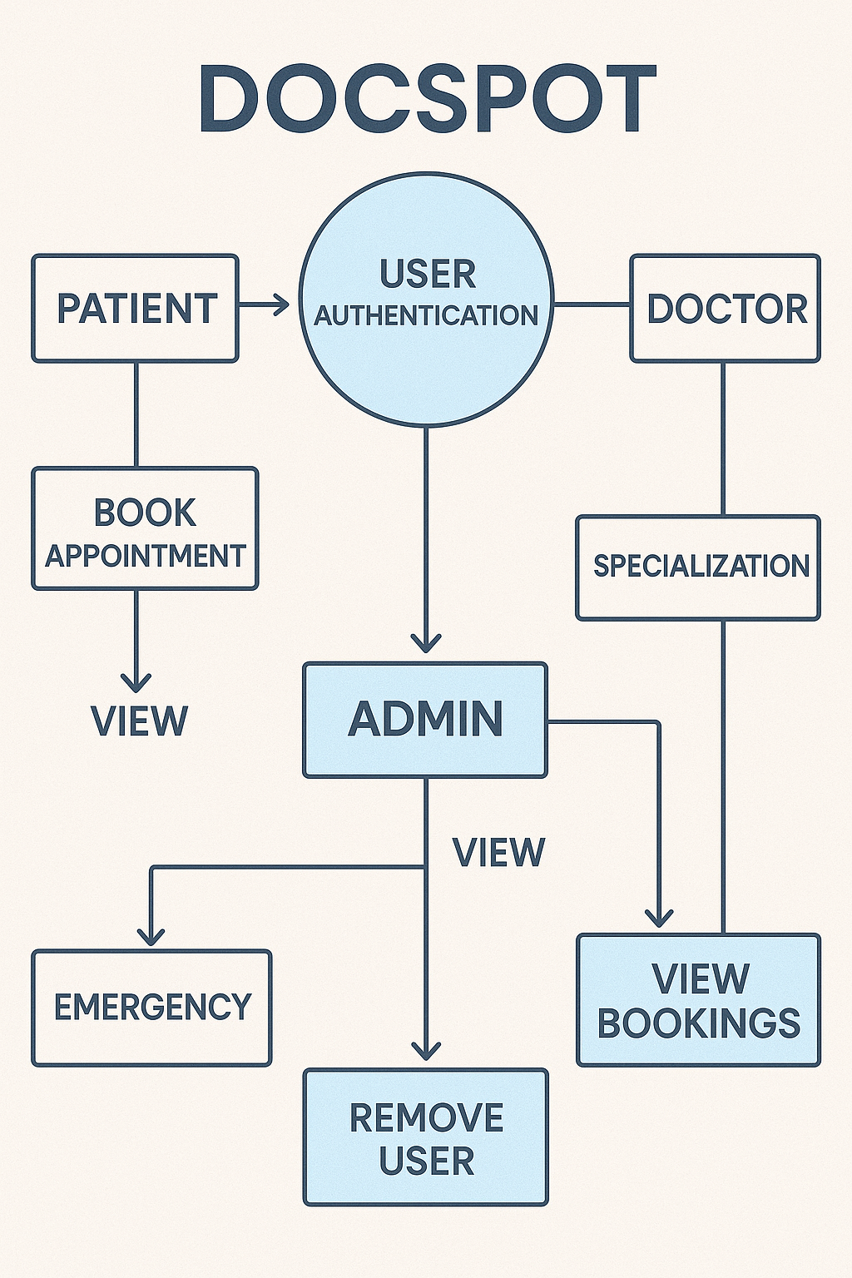

**User Stories**

**User Story Table – DocSpot**

| **User Type** | **Functional Requirement (Epic)** | **User Story / Task** | **Acceptance Criteria** | **Priority** | **Release** |
| --- | --- | --- | --- | --- | --- |
| | **Patient** | | --- |  |  | | --- | | | Appointment Booking | | --- | | As a patient, I can search for doctors by specialty and location. | Search results return relevant doctors. | High | Sprint-1 |
|  |  | As a patient, I can book, reschedule, or cancel appointments. | | Appointment status updates accordingly. | | --- |  |  | | --- | | Medium | Sprint-2 |
| | **Healthcare Provider** | | --- |  |  | | --- | | | Schedule Management | | --- |  |  | | --- | | | | As a provider, I can manage my availability calendar. | | --- |  |  | | --- | | | --- | --- | --- | | | Changes reflect immediately in patient booking system. | | --- |  |  | | --- | | High | Sprint-1 |
| **User** | Messaging | As a user, I can chat with the other party in real-time. | Messages appear instantly. | Medium | Sprint-2 |
| **Admin** | Profile Management | As a Admin, I can update my profile. | Changes are saved successfully. | High | Sprint-2 |
| **Client** | Payment Processing | As a client, I can make secure payments after job completion. | Payment recorded and shown in transaction history. | High | Sprint-2 |
| **user** | |  | | --- |  | Review System | | --- | | As a user, I can leave a review after project closure. | Review appears on profile. | Medium | Sprint-2 |
| **Admin** | User Moderation | As an admin, I can review reported users and take action. | Reports and actions logged. | High | Sprint-1 |